# KENDRIYA VIDYALAYA

C.L.R.I CHENNAI



**VIRTUAL PHONE**

Submitted To:

Smt. S. Kiran, PGT Computer Science Submitted by:

R. Rohan Bernard

Year: 2020-21

CERTIFICATE

This is to certify that the project **“Vitual Phone”** is a bonafide work, submitted in partial fulfillment as an investigatory project by Master R. Rohan Bernard of class XI-A for the academic year 2019-20 in the subject of computer science.

Place **:** Chennai - 600020

Date **:**

Signature of Teacher in Charge **:** Signature of External Examiner **:** Signature of principal **:**

Acknowledgment

## I would like to acknowledge my Computer science teacher Kiran mam PGT Computer Science for giving me support and motivation for successfully completing this project. I would also like to thank my parents for inspiring me to get the idea for this project and encouraging me. Finally I would like to thank my Classmates for bringing a competitive treak in me to make sure I complete this Project on time

CONTENTS



|  |  |  |
| --- | --- | --- |
| S.NO | Title | PAGE |
| 1 | Project Abstract |  |
| 2 | Overview |  |
| 3 | Source Code |  |
| 4 | Sample Output |  |
| 5 | Conclusion and future enhancements |  |
| 6 | bibliography |  |

**Project abstract**

This project is a basic model virtual phone with which you can use automatic online class attender, calculator, camera, diary, emailing facility, google, shin chan game, sms and wikipedia. When you click on the buttons it will open the app’s window. In every app there will be a button “how to use” in which if you click you can hear a voice instructing you how to use the app.

Overview

System Requirements

1. 14’+ monitor
2. Python 3.6.x
3. Minimum 4GB RAM

# Modules Imported

## Tkinter

## Pre-built module used for interface to the Tk GxUI toolkit.

## Os

## Pre-built module used for portable way of using operating system dependent functionality.

## Random

## Pre-built module used Generate pseudo-random numbers with various common distributions.

## Datetime

## Pre-built module used for supplies classes for manipulating dates and times.

## Time

## Pre-built module used for various time-related functions.

## pyttsx3

## Additional package installed for text to speech conversation.

## Webbrowser

## Additional package installed for opening a web page.

## Pynput

## Additional package installed to control and monitor input devices.

## Math

## Pre-built module used to access mathematical functions.

## Cv2

## Additional package installed for image and video processing.

## PIL

## Additional package installed for image processing.

## Csv

## Additional package installed for reading and writing an csv file.

## Smtplib

## Additional package installed to send mail to any Internet machine with an SMTP or ESMTP listener daemon.

## Email

## Additional package installed for managing email messages.

## Pygame

## Additional package installed for programming video games.

## Playsound

## Additional package installed to play audio clips.

## Requests

## Pre-built module used to request a webpage and get respons

## Wikipedia

## Additional package installed to access and parse data from Wikipedia.

Source Code

**phone.py**

from tkinter import *

import os

import random

from datetime import*

import pyttsx3

import time

ph=Tk()

ph.geometry("298x650")

ph.resizable(False, False)

ph.title("phone")

#cover

ph_photo = PhotoImage(file = "phone image.png")

phone=Label(ph,image=ph_photo,border=0)

phone.pack()

def power_off(event=True):

ph.destroy()

ph.bind("<Escape>",power_off)

exit_photo=PhotoImage(file="exit.png")

exit_but=Button(ph,image=exit_photo,border=0,command=power_off)

exit_but.place(x=195,y=432)

call_photo=PhotoImage(file="call.png")

call=Button(ph,image=call_photo,border=0)

call.place(x=28,y=432)

#Instruction

def instruc(event=True):

r=random.randint(0,1)

engine = pyttsx3.init()

voices = engine.getProperty('voices')

engine.setProperty('voice', voices[r].id)

rate = engine.getProperty('rate')

engine.setProperty('rate', rate-60)

engine.say("""welcome. This is a basic model virtual phone.

This phone contains automatic online class attender, calculator, camera, diary, emailing facility, google, shin chan game, sms and wikipedia.

If you click any of the app it will direct you to the app's window.

If you want to exit click back button or press escape.

Enjoy your virtual phone.

Handle with care.""")

engine.runAndWait()

ph.bind("?",instruc)

HTU_but=Button(ph,text="""HOW TO

USE.

(Press (?))""",border=0,bg="red2",fg="blue2",font=("Arial Black",11),command=instruc)

HTU_but.place(x=112,y=394,width=69,height=69)

back_photo=PhotoImage(file='back.png')

back=Button(ph,image=back_photo,border=0)

back.place(x=195,y=393)

opt_photo=PhotoImage(file='opt.png')

opt=Button(ph,image=opt_photo,border=0)

opt.place(x=28,y=393)

#calculator

def open_calc():

ph.destroy()

os.system('calculator.py')

calc_photo=PhotoImage(file = "calc.png")

calc=Button(ph,image=calc_photo,border=0,command=open_calc)

calc.place(x=120,y=145)

#class

def open_class():

ph.destroy()

os.system('class.py')

cal_photo=PhotoImage(file = "oc.png")

cal=Button(ph,image=cal_photo,border=0,command=open_class)

cal.place(x=45,y=145)

#diary

def open_diary(event=True):

ph.destroy()

os.system("diary.py")

diary_photo=PhotoImage(file='diary.png')

diary=Button(ph,image=diary_photo,border=0,command=open_diary)

diary.place(x=45,y=220)

#google

def open_web():

ph.destroy()

os.system("google.py")

google_photo=PhotoImage(file='google.png')

google=Button(ph,image=google_photo,border=0,command=open_web)

google.place(x=195,y=220)

#wikipedia

def open_wiki():

ph.destroy()

os.system("wiki.py")

wiki_photo=PhotoImage(file='wiki_image.png')

wiki=Button(ph,image=wiki_photo,border=0,command=open_wiki,bg="lime green")

wiki.place(x=195,y=295)

#camera

def open_cam():

ph.destroy()

os.system("camera.py")

cam_photo=PhotoImage(file='camera.png')

cam=Button(ph,image=cam_photo,border=0,command=open_cam)

cam.place(x=195,y=145)

# shin chan

def open_shin():

ph.destroy()

os.system('shin_game.py')

shin_photo=PhotoImage(file="shin_pic.png")

shin_chan=Button(ph,image=shin_photo,border=0,command=open_shin,bg="lime green")

shin_chan.place(x=45,y=295)

# Emailing

def open_email():

ph.destroy()

os.system("emailing.py")

email_photo=PhotoImage(file="mail.png")

email=Button(ph,image=email_photo,border=0,command=open_email)

email.place(x=120,y=220)

#Power off

def open_sms():

ph.destroy()

os.system("sms.py")

sms_photo=PhotoImage(file="sms.png")

sms=Button(ph,image=sms_photo,border=0,command=open_sms)

sms.place(x=120,y=295)

#date

today=time.strftime("%d/%m/%Y")

date=Label(ph,text=today,fg='black',font=('times', 16, 'bold'),bg="chocolate1")

date.place(x=74,y=106,width=150,height=28)

#time

time1 = ''

clock = Label(ph, font=('times', 18, 'bold'),bg="chocolate1")

clock.place(x=92,y=78,width=111,height=28)

def tick():

global time1

time2 = time.strftime('%H:%M')

if time2 != time1:

time1 = time2

clock.config(text=time2)

clock.after(200, tick)

tick()

#numbers

one=Button(ph,text="1",bg="red2",fg="blue2",border=0,font=("Arial Black",20))

one.place(x=28,y=474,width=70,height=22)

two=Button(ph,text="2",bg="red2",fg="blue2",border=0,font=("Arial Black",20))

two.place(x=112,y=474,width=70,height=22)

three=Button(ph,text="3",bg="red2",fg="blue2",border=0,font=("Arial Black",20))

three.place(x=196,y=474,width=70,height=22)

four=Button(ph,text="4",bg="red2",fg="blue2",border=0,font=("Arial Black",20))

four.place(x=28,y=512,width=70,height=22)

five=Button(ph,text="5",bg="red2",fg="blue2",border=0,font=("Arial Black",20))

five.place(x=112,y=512,width=70,height=22)

six=Button(ph,text="6",bg="red2",fg="blue2",border=0,font=("Arial Black",20))

six.place(x=196,y=512,width=70,height=22)

seven=Button(ph,text="7",bg="red2",fg="blue2",border=0,font=("Arial Black",20))

seven.place(x=28,y=548,width=70,height=23)

eight=Button(ph,text="8",bg="red2",fg="blue2",border=0,font=("Arial Black",20))

eight.place(x=112,y=548,width=70,height=23)

nine=Button(ph,text="9",bg="red2",fg="blue2",border=0,font=("Arial Black",20))

nine.place(x=196,y=548,width=70,height=23)

zero=Button(ph,text="0",bg="red2",fg="blue2",border=0,font=("Arial Black",20))

zero.place(x=112,y=586,width=70,height=29)

ash=Button(ph,text="#",bg="red2",fg="blue2",border=0,font=("Arial Black",20))

ash.place(x=196,y=586,width=70,height=29)

star=Button(ph,text="*",bg="red2",fg="blue2",border=0,font=("Arial Black",20))

star.place(x=28,y=586,width=70,height=29)

made=Label(ph,text="""

M

A

D

E

I

N

I

N

D

I

A""",font=(None,9),bg="black",fg="white")

made.place(x=280,y=100)

ph.mainloop()

**class.py**

import datetime

import webbrowser

import tkinter

from pynput.mouse import Button, Controller

import pynput

import random

import os

import pyttsx3

import time

mouse = Controller()

key=pynput.keyboard.Controller()

cl=tkinter.Tk()

cl.geometry("750x750")

cl.resizable(False, False)

bg_pic=tkinter.PhotoImage(file="oc_bg.png")

clbg=tkinter.Label(cl,image=bg_pic)

clbg.pack()

pic=tkinter.PhotoImage(file="oc_img.png")

bgpic=tkinter.Label(cl,image=pic,bg="antique white")

bgpic.place(x=70,y=10)

link=tkinter.Entry(cl,fg="gray",font=('Copperplate Gothic Bold',25))

link.insert(0,"Enter the class link")

link.place(x=80,y=400,width=600,height=50)

def clear_link(event):

link.delete(0, 'end')

link['fg'] = 'black'

link.unbind("<FocusIn>")

return None

link.bind("<FocusIn>", clear_link)

def meet():

l=link.get()

if l=="Enter the class link":

None

else:

global mouse

global key

webbrowser.open(l)

time.sleep(10)

##MAXIMIZE

key.press(pynput.keyboard.Key.alt)

key.press(pynput.keyboard.Key.space)

key.release(pynput.keyboard.Key.space)

key.release(pynput.keyboard.Key.alt)

time.sleep(2)

key.press('x')

key.release('x')

time.sleep(2)

##mute mic

mouse.position = (494,655)

mouse.press(Button.left)

mouse.release(Button.left)

time.sleep(3)

##mute camera

mouse.position = (577,655)

mouse.press(Button.left)

mouse.release(Button.left)

time.sleep(3)

##Join

mouse.position = (1127,492)

mouse.press(Button.left)

mouse.release(Button.left)

time.sleep(3)

start=tkinter.Button(cl,text="JOIN",bg="dark violet",font=("Copperplate Gothic Bold",24),command=meet)

start.place(x=325,y=470,width=100,height=50)

cl.bind('<Return>',meet)

def ph_open(event=True):

cl.destroy()

os.system("phone.py")

back=tkinter.Button(cl,text="EXIT",bg="DarkGoldenrod2",font=("Copperplate Gothic Bold",24),command=ph_open)

back.place(x=100,y=550,width=150,height=150)

cl.bind('<Escape>',ph_open)

#Instruction

def instruc(event=True):

r=random.randint(0,1)

engine = pyttsx3.init()

voices = engine.getProperty('voices')

engine.setProperty('voice', voices[r].id)

rate = engine.getProperty('rate')

engine.setProperty('rate', rate-50)

engine.say("""Welcome to online class. In this app you need to give the class link and sit back and see the automatic class joining function.

You need to do,

Step 1, Paste your class link the space provided.

Step 2, Click join button or press enter key.

stay relaxed and see the system joining itself without any disturbance.

Have a nice day.""")

engine.runAndWait()

HTU=tkinter.Button(cl,text="""HOW TO

USE

press (?)""",bg="SeaGreen3",font=("Copperplate Gothic Bold",24),command=instruc)

HTU.place(x=500,y=550,width=150,height=150)

cl.mainloop()

**calculator.py**

from tkinter import*

import math

import os

import pyttsx3

import random

calc = Tk()

calc.resizable(False, False)

ph_photo = PhotoImage(file = "phone image.png")

phone=Label(calc,image=ph_photo,border=0)

phone.pack()

call_photo=PhotoImage(file="call.png")

call=Button(calc,image=call_photo,border=0)

call.place(x=28,y=432)

#Instruction

def instruc(event=True):

engine = pyttsx3.init()

r=random.randint(0,1)

voices = engine.getProperty('voices')

engine.setProperty('voice', voices[r].id)

rate = engine.getProperty('rate')

engine.setProperty('rate', rate-60)

engine.say("""welcome to the world of calculations. In this app you can do the mathematic calculations.

For that you need to do,

step 1, enter the calculations. Example, 2+3. you can type in your device or else click the buttons provided.

step 2, press the equal to button in the phone or enter key in your device to see the result.

step 3, if you want to continue with that result click or press the any symbol key and give your numbers.

If you to clear you can click on the AC button or C button or else press escape key in your device.

If you want to go back to the main menu click on the back button.

Enjoy your calculations""")

engine.runAndWait()

start_but=Button(calc,text="""HOW TO

USE""",border=0,bg="lightblue",fg="green",font=("Arial Black",11),command=instruc)

start_but.place(x=112,y=394,width=69,height=69)

back_photo=PhotoImage(file='back.png')

back=Button(calc,image=back_photo,border=0)

back.place(x=195,y=393)

opt_photo=PhotoImage(file='opt.png')

opt=Button(calc,image=opt_photo,border=0)

opt.place(x=28,y=393)

def open_ph(event=True):

calc.destroy()

os.system("phone.py")

exit_photo=PhotoImage(file="exit.png")

exit_but=Button(calc,image=exit_photo,border=0,command=open_ph)

exit_but.place(x=195,y=432)

class Calc:

def getandreplace(self):

self.txt = self.e.get()

self.txt = self.txt.replace('÷', '/')

self.txt = self.txt.replace('x', '*')

self.txt = self.txt.replace('%', '/100')

def evaluation(self, specfunc):

self.getandreplace()

try:

self.txt = eval(str(self.txt))

except SyntaxError:

self.displayinvalid()

else:

if any([specfunc == 'sqph', specfunc == 'power']):

self.txt = self.evalspecialfunctions(specfunc)

self.refreshtext()

def displayinvalid(self):

self.e.delete(0, END)

self.e.insert(0, 'Invalid Input!')

def refreshtext(self):

self.e.delete(0, END)

self.e.insert(0, self.txt)

def evalspecialfunctions(self, specfunc):

if specfunc == 'sqph':

return math.sqrt(float(self.txt))

elif specfunc == 'power':

return math.pow(float(self.txt), 2)

def clearall(self):

self.e.delete(0, END)

self.e.insert(0, '0')

def clear1(self, event=None):

if event is None:

self.txt = self.e.get()[:-1]

else:

self.txt = self.getvalue()

self.refreshtext()

def action(self, argi: object):

self.txt = self.getvalue()

self.stripfirstchar()

self.e.insert(END, argi)

def keyaction(self, event=None):

self.txt = self.getvalue()

if any([event.char.isdigit(), event.char in '/*-+%().']):

self.stripfirstchar()

elif event.char == '\x08':

self.clear1(event)

elif event.char == '\x1b':

self.clearall()

elif event.char == '\r':

self.evaluation('eq')

else:

self.displayinvalid()

return 'break'

def stripfirstchar(self):

if self.txt[0] == '0':

self.e.delete(0, 1)

def getvalue(self):

return self.e.get()

def __init__(self,master):

self.txt = 'o'

master.title('Calulator')

master.geometry('235x512')

self.e = Entry(master,bg="lightgreen",fg="blue",font=('times',20,"bold"),border=5)

self.e.place(x=34, y=78,width=228,height=50)

self.e.insert(0, '0')

self.e.focus_set()

Button(master, text="=", width=21,bg='green',font=("Arial Black",20), command=lambda: self.evaluation('eq')).place(x=33, y=310,width=232,height=50)

Button(master, text='AC', bg='green',font=("Arial Black",20), command=lambda: self.clearall()).place(x=151, y=260,width=56,height=50)

Button(master, text='C', bg='green',font=("Arial Black",20), command=lambda: self.clear1()).place(x=210, y=260,width=56,height=50)

Button(master, text="+", bg='white',font=("Arial Black",20), command=lambda: self.action('+')).place(x=33, y=160,width=56,height=50)

Button(master, text="x", bg='white',font=("Arial Black",20), command=lambda: self.action('x')).place(x=151, y=160,width=56,height=50)

Button(master, text="-", bg='white',font=("Arial Black",20), command=lambda: self.action('-')).place(x=92, y=160,width=56,height=50)

Button(master, text="÷", bg='white',font=("Arial Black",20), command=lambda: self.action('÷')).place(x=210, y=160,width=56,height=50)

Button(master, text="%", bg='white',font=("Arial Black",20), command=lambda: self.action('%')).place(x=210, y=210,width=56,height=50)

Button(master, text="#",bg="lightblue",fg="green",font=("Arial Black",20),border=0,command=lambda: self.action('#')).place(x=196,y=586,width=70,height=29)

Button(master, text="*",bg="lightblue",fg="green",font=("Arial Black",20),border=0,command=lambda: self.action('*')).place(x=28,y=586,width=70,height=29)

Button(master, text="7",bg="lightblue",fg="green",font=("Arial Black",20),border=0,command=lambda: self.action('7')).place(x=28,y=548,width=70,height=23)

Button(master, text="8",bg="lightblue",fg="green",font=("Arial Black",20),border=0,command=lambda: self.action('8')).place(x=112,y=548,width=70,height=23)

Button(master, text="9",bg="lightblue",fg="green",font=("Arial Black",20),border=0,command=lambda: self.action('9')).place(x=196,y=548,width=70,height=23)

Button(master, text="4",bg="lightblue",fg="green",font=("Arial Black",20),border=0,command=lambda: self.action('4')).place(x=28,y=512,width=70,height=22)

Button(master, text="5",bg="lightblue",fg="green",font=("Arial Black",20),border=0,command=lambda: self.action('5')).place(x=112,y=512,width=70,height=22)

Button(master, text="6",bg="lightblue",fg="green",font=("Arial Black",20),border=0,command=lambda: self.action('6')).place(x=196,y=512,width=70,height=22)

Button(master, text="1",bg="lightblue",fg="green",font=("Arial Black",20),border=0,command=lambda: self.action('1')).place(x=28,y=474,width=70,height=22)

Button(master, text="2",bg="lightblue",fg="green",font=("Arial Black",20),border=0,command=lambda: self.action('2')).place(x=112,y=474,width=70,height=22)

Button(master, text="3",bg="lightblue",fg="green",font=("Arial Black",20),border=0,command=lambda: self.action('3')).place(x=196,y=474,width=70,height=22)

Button(master, text="0", bg="lightblue",fg="green",font=("Arial Black",20),border=0, command=lambda: self.action('0')).place(x=112,y=586,width=70,height=29)

Button(master, text=".", bg='white',font=("Arial Black",20), command=lambda: self.action('.')).place(x=33, y=210,width=56,height=50)

Button(master, text="(",bg='green',font=("Arial Black",20), command=lambda: self.action('(')).place(x=33, y=260,width=56,height=50)

Button(master, text=")", bg='green',font=("Arial Black",20), command=lambda: self.action(')')).place(x=92, y=260,width=56,height=50)

Button(master, text="√", bg='white',font=("Arial Black",20), command=lambda: self.evaluation('sqph')).place(x=151, y=210,width=56,height=50)

Button(master, text="x²", bg='white',font=("Arial Black",20), command=lambda: self.evaluation('power')).place(x=92, y=210,width=56,height=50)

self.e.bind('<Key>', lambda evt: self.keyaction(evt))

obj=Calc(calc)

calc.geometry("298x650")

calc.mainloop()

**camera.py**

import tkinter

import cv2

import os

import PIL.Image, PIL.ImageTk

import random

import time

import pyttsx3

class App:

def __init__(self, cam,window_title, video_source=0):

self.cam = cam

self.cam.title(window_title)

self.cam.geometry("750x750")

self.cam.resizable(False, False)

self.cam.attributes('-topmost', True)

self.cam.update()

self.cam.attributes('-topmost', False)

self.video_source = video_source

self.vid = MyVideoCapture(self.video_source)

self.cambg=tkinter.PhotoImage(file="cam_bg.png")

self.bg=tkinter.Label(cam,image=self.cambg)

self.bg.pack()

self.canvas =tkinter.Canvas(cam, width = self.vid.width, height = self.vid.height,bg='cyan2',border=0)

self.canvas.place(x=55,y=30)

def message(event=True):

self.flash_pic=tkinter.PhotoImage(file="flash.png")

self.flash=tkinter.Label(cam,image=self.flash_pic)

self.flash.place(x=55,y=30)

self.flash.after(500,self.flash.destroy)

self.msg=tkinter.Label(cam,text="CAPTURED",bg='lawn green',font=("Berlin Sans FB Demi",80),fg='blue')

self.msg.place(x=55,y=200,width=640)

self.cam.after(1000,self.msg.destroy)

self.ins=tkinter.Label(cam,text="""Press 'c' to take a pic

and

Press 'esc' to return back""",anchor="e",bg='cyan2',font=("Berlin Sans FB Demi",30),fg='brown')

self.ins.place(x=55,y=550,width=640)

cam.bind('c',self.snapshot)

self.btn_snapshot=tkinter.Button(cam, text="Snapshot",width=24,font=("Castellar",12,"bold"),bg='cyan2',

activebackground='green', command=lambda:[self.snapshot(),message()])

self.btn_snapshot.place(x=375,y=510,width=320,height=40)

cam.bind("<Escape>",self.back)

self.btn_back=tkinter.Button(cam,text="EXIT",font=("Castellar",12,"bold"),bg='cyan2',command=self.back)

self.btn_back.place(x=55,y=510,width=320,height=40)

self.emoji_pic=tkinter.PhotoImage(file="selfie.png")

self.emoji=tkinter.Label(cam,image=self.emoji_pic,border=0)

self.emoji.place(x=55,y=550)

#Instructions

def instruc(event=True):

r=random.randint(0,1)

engine = pyttsx3.init()

voices = engine.getProperty('voices')

engine.setProperty('voice', voices[r].id)

rate = engine.getProperty('rate')

engine.setProperty('rate', rate-60)

engine.say("""Welcome to the world of pictures.

Here you can take selfie of your or with your friends.

If you want to selfie click on the button snapshot or press C.

If you want to return to the main menu click on the button exit or press escape in your device.

Help other with a smile.""")

engine.runAndWait()

cam.bind("?",instruc)

self.HTU=tkinter.Button(cam,text="""HOW TO USE""",border=0,bg='cyan2',fg="green",font=("Berlin Sans FB Demi",30),command=instruc)

self.HTU.place(x=225,y=690,width=250,height=60)

self.delay = 15

self.update()

self.cam.mainloop()

def back(self,event=True):

self.cam.destroy()

os.system("phone.py")

def snapshot(self,event=True):

ret, frame = self.vid.get_frame()

if ret:

cv2.imwrite("capture-" + time.strftime("%d-%m-%Y-%H-%M-%S") + ".jpg", cv2.cvtColor(frame, cv2.COLOR_RGB2BGR))

def update(self):

ret, frame = self.vid.get_frame()

if ret:

self.photo = PIL.ImageTk.PhotoImage(image = PIL.Image.fromarray(frame))

self.canvas.create_image(0, 0, image = self.photo, anchor = tkinter.NW)

self.cam.after(self.delay, self.update)

class MyVideoCapture:

def __init__(self, video_source=0):

self.vid = cv2.VideoCapture(video_source)

if not self.vid.isOpened():

raise ValueError("Unable to open video source", video_source)

self.width = self.vid.get(cv2.CAP_PROP_FRAME_WIDTH)

self.height = self.vid.get(cv2.CAP_PROP_FRAME_HEIGHT)

def get_frame(self):

if self.vid.isOpened():

ret, frame = self.vid.read()

if ret:

return (ret, cv2.cvtColor(frame, cv2.COLOR_BGR2RGB))

else:

return (ret, None)

else:

return (ret, None)

def __del__(self):

if self.vid.isOpened():

self.vid.release()

App(tkinter.Tk(), "CAMERA")

**diary.py**

from tkinter import*

import csv

import os

import pyttsx3

import random

import datetime

dtk=Tk()

dtk.resizable(False, False)

dtk.geometry('1000x750')

today=datetime.date.today()

diary_back = PhotoImage(file = "diary_back2.png")

back=Label(dtk,image=diary_back,border=0)

back.pack(anchor=CENTER)

mem=Text(dtk,bg='darkslategray1',fg='green',font=["Comic Sans MS",20])

mem.insert(INSERT, '\n')

mem.insert(INSERT, '\n')

mem.place(x=125,y=190,width=750,height=445)

d=int(today.strftime("%d"))

m=int(today.strftime("%m"))

y=int(today.strftime("%Y"))

date_dm=Label(dtk,text=(d,'/',m),fg='green',font=["Comic Sans MS",18])

date_dm.place(x=300,y=120)

date_y=Label(dtk,text=(y),fg='green',font=["Comic Sans MS",18])

date_y.place(x=300,y=150)

days=datetime.datetime.today().strftime("%a")

def ph_open(event=True):

dtk.destroy()

os.system("phone.py")

dtk.bind("<Escape>",ph_open)

back=Button(dtk,text="BACK",fg="blue",bg="pink",font=["Comic Sans MS",18],command=ph_open)

back.place(x=0,y=0,width=125,height=50)

day=Label(dtk,text=(days),fg='green',font=["Comic Sans MS",25])

day.place(x=618,y=135)

spe=Entry(dtk,fg="grey",bg='yellow',font=["Comic Sans MS",18],justify="center")

spe.insert(0,"Enter today's special")

spe.place(x=250,y=190,width=500,height=50)

def special(event):

spe.delete(0, "end")

spe['fg'] = 'red'

spe['bg']='yellow'

spe.unbind("<FocusIn>")

return None

spe.bind("<FocusIn>", special)

def saving():

spec=spe.get()

memo=mem.get("1.0","end-1c")

memo=memo.replace("\n\n","")

with open("diary.csv","a") as csvfile:

mywriter=csv.writer(csvfile,delimiter=',')

mywriter.writerow([d,m,y,spec,memo])

save=Button(dtk,text="SAVE",fg='cyan',bg='green',font=["Comic Sans MS",18,"bold"],command=saving)

save.place(x=885,y=265,width=105,height=70)

def displaying():

dis=Toplevel()

dis.resizable(False, False)

dis.geometry("600x600")

dis.configure(bg="white")

date=Entry(dis,font=(None,20))

date.place(x=110,y=10,width=50,height=50)

month=Entry(dis,font=(None,20))

month.place(x=160,y=10,width=50,height=50)

year=Entry(dis,font=(None,20))

year.place(x=210,y=10,width=80,height=50)

date_lab=Label(dis,text="DATE :",font=["Comic Sans MS",20])

date_lab.place(x=10,y=10)

dmy=Label(dis,text="DD/MM/YYYY",bg="red",font=(None,20))

dmy.place(x=110,y=70,width=180,height=50)

def getting():

d=int(date.get())

m=int(month.get())

y=int(year.get())

with open("diary.csv",mode="r") as csvfile:

myreader=csv.reader(csvfile,delimiter=",")

for row in myreader:

if len(row)!=0:

if int(row[0])==d:

if int(row[1])==m:

if int(row[2])==y:

result=("\nMemories :",row[4])

label1=Label(dis,text=("SpecialEvent :",row[3]),bg="white",font=["Comic Sans MS",18])

label1.place(x=0,y=130,width=600,height=40)

label2=Text(dis,bg="lightblue",fg="red2",font=["Comic Sans MS",25])

label2.insert(END,("Memories :",row[4]))

label2.place(x=0,y=170,width=600,height=430)

check=Button(dis,text="check",bg="white",fg="green",font=["Comic Sans MS",25],command=getting)

check.place(x=300,y=10,width=110,height=110)

def exiting():

dis.destroy()

back=Button(dis,text="QUIT",bg="white",fg="green",font=["Comic Sans MS",25],comman=exiting)

back.place(x=420,y=10,width=110,height=110)

display=Button(dtk,text="DISPLAY",fg='cyan',bg='green',font=["Comic Sans MS",16,"bold"],command=displaying)

display.place(x=10,y=265,width=105,height=70)

#Instruction

def instruc(event=True):

r=random.randint(0,1)

engine = pyttsx3.init()

voices = engine.getProperty('voices')

engine.setProperty('voice', voices[r].id)

rate = engine.getProperty('rate')

engine.setProperty('rate', rate-50)

engine.say("""Welcome to the world of memories.

Here you can maintain your personal diary.

step 1 . In the yellow box enter that day's special event.

step 2 . In the blue box enter your memories of the day.

step 3 . Click save.

If you want to see your old memories click display and it opens a new window,

there you are given three boxes if the first box enter the date, in the second box enter the month, and, in the third box enter the year.

then click ckeck button.

Your memories would be displayed.

Have a great days.""")

engine.runAndWait()

dtk.bind("?",instruc)

instr=Button(dtk,text="""HOW TO

USE (?)""",bg="white",fg="green",font=["Comic Sans MS",16,"bold"],comman=instruc)

instr.place(x=10,y=140,width=105,height=70)

dtk.mainloop()

**emailing.py**

import smtplib

from tkinter import*

from email.message import EmailMessage

import os

import time

import random

import pyttsx3

em=Tk()

em.resizable(False, False)

em.geometry("750x750")

bg_photo=PhotoImage(file="email_bg.png")

bg=Label(em,image=bg_photo)

bg.place(x=0,y=0)

user_id=Entry(em,fg='grey',bg="dodgerblue3",font=("CGill Sans MT",20))

user_id.insert(0,"Enter your friend's email id")

user_id.place(x=80,y=25,width=500,height=50)

def clear_user(event):

user_id.delete(0, "end")

user_id['fg']='black'

user_id.unbind("<FocusIn>")

user_id.bind("<FocusIn>", clear_user)

subject=Entry(em,fg='grey',bg="dark turquoise",font=("CGill Sans MT",20))

subject.insert(0,"Subject")

subject.place(x=80,y=100,width=500,height=50)

def clear_subject(event):

subject.delete(0, "end")

subject['fg']='black'

subject.unbind("<FocusIn>")

subject.bind("<FocusIn>", clear_subject)

msg_box=Text(em,bg='red',font=("CGill Sans MT",20))

msg_box.place(x=0,y=200,width=750,height=550)

def send():

u=user_id.get()

if "@gmail.com" in u:

None

else:

u=u+"@gmail.com"

s=subject.get()

message=msg_box.get("1.0", "end-1c")

m = EmailMessage()

m["From"] = "basicphone2020@gmail.com"

m["Subject"] = s

m["To"] = u

m.set_content(message)

s = smtplib.SMTP('smtp.gmail.com', 587)

s.ehlo()

s.starttls()

s.login('basicphone2020@gmail.com', 'simplyphone')

s.send_message(m)

sent_msg=Label(em,text="SENT",bg="yellow",font=("Rockwell",20))

sent_msg.place(x=335,y=160,width=80)

em.after(1000,sent_msg.destroy)

send_pic=PhotoImage(file="send.png")

send=Button(em,image=send_pic,command=send)

send.place(x=600,y=25)

def ph_open(event=True):

em.destroy()

os.system("phone.py")

def clearing(event=True):

user_id.delete(0, "end")

subject.delete(0, "end")

msg_box.delete('1.0', END)

em.bind("<Escape>",clearing)

back=Button(em,text="EXIT",font=("CGill Sans MT",20),bg="deep pink",command=ph_open)

back.place(x=10,y=10,width=60,height=40)

#Instructions

def instruc(event=True):

r=random.randint(0,1)

engine = pyttsx3.init()

voices = engine.getProperty('voices')

engine.setProperty('voice', voices[r].id)

rate = engine.getProperty('rate')

engine.setProperty('rate', rate-50)

engine.say("""Welcome to world of internet.

Here you can send mail to your friends through gmail.

for that you need to do,

step 1, enter your friends email address, in this you can type with gmail dor com or without gmail dot com,

for example let xyz be the user,

in the username box xyz@gmail.com is valid xyz is also valid.

step 2, Enter the subject of sending this mail.

step 3, Start to type your message.

step 4, click on the send button.

A sent message will be displayed.

Your mail has been sent to your friend.

If you want to send one more email press escape.

If you want to go to main menu click exit button.

Have a great emailing time.""")

engine.runAndWait()

em.bind("?",instruc)

HTU=Button(em,text="""HOW

TO

USE

(?)""",font=("CGill Sans MT",16),bg="sea green",command=instruc)

HTU.place(x=10,y=60,width=60,height=120)

em.mainloop()

**google.py**

from tkinter import *

import pyttsx3

import webbrowser

import random

import os

ggl=Tk()

ggl.geometry("750x750")

ggl.config(bg='white')

ggl.resizable(False, False)

search=Entry(ggl,font=('Eras Bold ITC',20),fg="gray")

search.insert(0,"Enter your search")

search.place(x=125,y=300,width=500,height=50)

def clear_search(event):

search.delete(0, END)

search['fg'] = 'black'

search.unbind("<FocusIn>")

return None

search.bind("<FocusIn>", clear_search)

def getting(event=True):

val=search.get()

webbrowser.open("https://www.google.com/search?q=" + val)

search.delete(0,END)

ser=Button(ggl,text="SEARCH",bg='firebrick1',font=('times',20,"bold"),command=getting)

ser.place(x=300,y=400,width=150,height=50)

ggl.bind("<Return>",getting)

ggl_pic=PhotoImage(file="google_txt.png")

ggl_label=Label(ggl,image=ggl_pic,bg='white')

ggl_label.place(x=50,y=50)

def ph_open(event=True):

ggl.destroy()

os.system("phone.py")

back=Button(ggl,text="BACK",font=("Copperplate Gothic Bold",28),bg='PaleVioletRed2',command=ph_open)

back.place(x=100,y=500,width=200,height=200)

ggl.bind("<Escape>",ph_open)

#Instructions

def instruc(event=True):

r=random.randint(0,1)

engine = pyttsx3.init()

voices = engine.getProperty('voices')

engine.setProperty('voice', voices[r].id)

rate = engine.getProperty('rate')

engine.setProperty('rate', rate-50)

engine.say("""Welcome to google. In this app you can use it as google search.

step 1, in the search box, enter you search.

step 2, click on the search button or press enter key. You will be directed to the google page.

If you want to got to main menu click on the quit button or press escape key.

Have a nice day.""")

engine.runAndWait()

ggl.bind("?",instruc)

HTU=Button(ggl,text="""HOW TO

USE (?)""",font=("Copperplate Gothic Bold",28),bg='cornflower blue',command=instruc)

HTU.place(x=450,y=500,width=200,height=200)

ggl.mainloop()

**shin_chan.py**

import pygame

from pygame import mixer

import random

import os

import time

import playsound

pygame.init()

w=1200

h=700

Qx=1050

Qy=640

black = (0,0,0)

white = (255,255,255)

red = (200,0,0)

green = (0,200,0)

blue = (0,0,205)

bright_red = (255,0,0)

bright_green = (0,255,0)

bright_blue = (0,128,255)

shin_width = 149

shin_height = 200

gameDisplay = pygame.display.set_mode((w,h))

pygame.display.set_caption('ShinChan Game')

clock = pygame.time.Clock()

#Images

background=pygame.image.load('sc_bg.png')

shinImg =pygame.image.load('shinchan.png')

kamenin=pygame.image.load('action kamen.png')

menu_bg=pygame.image.load("menu.png")

lost=pygame.image.load("beated.png")

lost_bg=pygame.image.load("hell.png")

misae=pygame.image.load("misae.png")

dialouge=pygame.image.load("misae dia.png")

lt=pygame.image.load("arr_left.png")

rt=pygame.image.load("arr_right.png")

ins_bg=pygame.image.load("ins_bg.png")

#Sounds

drop_sound=mixer.Sound("end beat.mp3")

catch=mixer.Sound("catch.mp3")

def shin_score(count):

font = pygame.font.SysFont("Eras Bold ITC", 80)

text = font.render("score: "+str(count), True, black)

gameDisplay.blit(text,(0,0))

def dropcount(drop_count):

drop_font = pygame.font.SysFont("Eras Bold ITC", 80)

drop_text= drop_font.render("DROPPED: "+str(drop_count), True, black)

gameDisplay.blit(drop_text,(w-350,0))

def things(kamenx, kameny, thingw, thingh):

gameDisplay.blit(kamenin,(kamenx,kameny))

def shin(x,y):

gameDisplay.blit(shinImg,(x,y))

def text_objects(text, font):

textSurface = font.render(text, True, black)

return textSurface, textSurface.get_rect()

def message_display(text):

largeText = pygame.font.Font('freesansbold.ttf',115)

TextSurf, TextRect = text_objects(text, largeText)

TextRect.center = ((w/2),(h/2))

gameDisplay.blit(TextSurf, TextRect)

pygame.display.update()

def button(msg,Bx,By,Bw,Bh,ic,ac,action=None):

mouse = pygame.mouse.get_pos()

click = pygame.mouse.get_pressed()

if Bx+Bw > mouse[0] > Bx and By+Bh > mouse[1] > By:

pygame.draw.rect(gameDisplay, ac,(Bx,By,Bw,Bh))

if click[0] == 1 and action != None:

action()

else:

pygame.draw.rect(gameDisplay, ic,(Bx,By,Bw,Bh))

Button_Text = pygame.font.SysFont("Eras Bold ITC",50)

textSurf, textRect = text_objects(msg, Button_Text)

textRect.center = ( (Bx+100), (By+70) )

gameDisplay.blit(textSurf, textRect)

def droped():

gameDisplay.blit(lost_bg,(0,0))

message_display('You lost')

gameDisplay.blit(misae,(510,50))

gameDisplay.blit(dialouge,(750,0))

gameDisplay.blit(lost,((w/2-100),(h/2+50)))

mixer.Sound.play(drop_sound)

mixer.music.stop()

pygame.display.update()

intro=True

while intro:

for event in pygame.event.get():

if event.type == pygame.QUIT:

pygame.quit()

quit()

button("Play Again",200,450,200,150,green,bright_green,game_loop)

button("Quit",800,450,200,150,red,bright_red,quitgame)

pygame.display.update()

clock.tick(60)

def instruc(text,x,y):

font = pygame.font.SysFont("Eras Bold ITC", 50)

Text= font.render(text, True, blue)

gameDisplay.blit(Text,(x,y))

def inst():

gameDisplay.blit(ins_bg,(0,0))

mixer.music.load("music.mp3")

mixer.music.play(-1)

ins=True

while ins:

for event in pygame.event.get():

if event.type == pygame.QUIT:

pygame.quit()

quit()

instruc("Shin Chan has to clean his room. ",10,20)

instruc("So kindly help him.",10,65)

instruc("He has to catch the falling toys and",10,100)

instruc("if he catches one toy he gets one point.",10,135)

instruc("or else if he drop, drop point increases",10,170)

instruc("toys can be catched only using hands",10,205)

instruc("press left arrow key to move left",10,240)

instruc("press right arrow key to move right",10,275)

gameDisplay.blit(lt,(10,380))

gameDisplay.blit(rt,(150,380))

button("PLAY",100,500,220,150,green,bright_green,game_loop)

pygame.display.update()

def quitgame():

pygame.quit()

os.system("phone.py")

def menu():

while True:

for event in pygame.event.get():

if event.type == pygame.QUIT:

pygame.quit()

quit()

gameDisplay.blit(menu_bg,(0,0))

largeText = pygame.font.SysFont("Eras Bold ITC",115)

TextSurf, TextRect = text_objects("""Shin Chan's Catch the toys""", largeText)

TextRect.center = ((w/2),100)

gameDisplay.blit(TextSurf, TextRect)

button("PLAY",50,500,200,150,green,bright_green,game_loop)

button("HOW TO",270,500,200,150,blue,bright_blue,inst)

button("Quit",500,500,200,150,red,bright_red,quitgame)

pygame.display.update()

clock.tick(15)

def game_loop():

playsound.playsound("start play.mp3")

x = (w * 0.5)-shin_width*0.5

y = h-shin_height

mixer.music.load("intro.mp3")

mixer.music.play(-1)

x_change = 0

oppos = 10

kamenw = 120

kamenh = 200

kamen_startx = random.randrange(0, w-kamenw)

kamen_starty = 0-kamenh

thingCount = 1

score = 0

drop=5

gameExit = False

while not gameExit:

gameDisplay.blit(background,(0,0))

for event in pygame.event.get():

if event.type == pygame.QUIT:

pygame.quit()

quit()

if event.type == pygame.KEYDOWN:

if event.key == pygame.K_LEFT:

x_change = -10

if event.key == pygame.K_RIGHT:

x_change = 10

if event.type == pygame.MOUSEBUTTONDOWN:

mouse_pos=event.pos

if Qbut.collidepoint(mouse_pos):

gameExit = False

os.system("phone.py")

if event.type == pygame.KEYUP:

if event.key == pygame.K_LEFT or event.key == pygame.K_RIGHT:

x_change = 0

x += x_change

things(kamen_startx, kamen_starty, kamenw, kamenh)

kamen_starty += oppos

shin(x,y)

shin_score(score)

dropcount(drop)

if x+shin_width > w :

x=0+shin_width

if x < 0:

x=w-shin_width

if kamen_starty > h:

kamen_starty = 0 - kamenh

kamen_startx = random.randrange(0,w-kamenw)

drop -= 1

if y < kamen_starty+kamenh :

if x > kamen_startx and x < kamen_startx + kamenw or x+shin_width > kamen_startx and x + shin_width < kamen_startx+kamenw:

score+=1

kamen_starty = 0 - kamenh

kamen_startx = random.randrange(0,w-kamenw)

mixer.Sound.play(catch)

if drop==0:

for event in pygame.event.get():

if event.type == pygame.MOUSEBUTTONDOWN:

mouse_pos=event.pos

if EQbut.collidepoint(mouse_pos):

gameloop()

droped()

pygame.display.update()

clock.tick(60)

menu()

game_loop()

pygame.quit()

quit()

**sms.py**

import requests

from tkinter import*

import random

import pyttsx3

import os

msg=Tk()

msg.geometry("750x750")

msg.resizable(False, False)

sms_bg=PhotoImage(file="sms_bg.png")

bg=Label(msg,image=sms_bg)

bg.pack()

num=Entry(msg,fg='grey',bg="darkgoldenrod1",font=("CGill Sans MT",20))

num.insert(0,"Enter the number")

num.place(x=90,y=50,width=500,height=50)

msg_box=Text(msg,bg='medium blue',font=("CGill Sans MT",20))

msg_box.insert(END,"Enter you message")

msg_box.place(x=0,y=200,width=750,height=550)

def clear_num(event):

num.delete(0, "end")

num['fg']='black'

num.unbind("<FocusIn>")

num.bind("<FocusIn>", clear_num)

def send(event=True):

number=num.get()

mes=msg_box.get("1.0", "end-1c")

url = "https://www.fast2sms.com/dev/bulk"

payload = "sender_id=FSTSMS&language=english&route=p&message=&numbers="

mes="message="+mes

number="numbers="+number

payload = payload.replace("message=",mes)

payload = payload.replace("numbers=",number)

headers = {

'authorization': "Gn1kiNRhTIqYVrHfuz0mB7e32yM8dEjgZXP5LWtJ4xF6wsbvOcOwmHpyPNRgl897nBWK1UjAuFQk2rTS",

'Content-Type': "application/x-www-form-urlencoded",

'Cache-Control': "no-cache",

}

sent_msg=Label(msg,text="SENT",bg="purple",font=("Rockwell",20))

sent_msg.place(x=335,y=120,width=80)

msg.after(1000,sent_msg.destroy)

response = requests.request("POST", url, data=payload, headers=headers)

print(response.text)

def clear_mes(event):

msg_box.delete("1.0","end")

msg_box['fg']='black'

msg_box.unbind("<FocusIn>")

msg_box.bind("<FocusIn>", clear_mes)

sendpic=PhotoImage(file="msg_send.png")

send=Button(msg,image=sendpic,bg="lime green",command=send)

send.place(x=600,y=25,width=150,height=150)

msg.bind("<Return>",send)

heading=Label(msg,text="MESSAGE",bg="blue",fg="green2",font=(None,20))

heading.place(x=300,y=10)

def ph_open(event=True):

msg.destroy()

os.system("phone.py")

msg.bind("<Escape>",ph_open)

back=Button(msg,text="EXIT",font=("CGill Sans MT",20),bg="green4",command=ph_open)

back.place(x=10,y=10,width=60,height=40)

#Instruction

def instruc(event=True):

r=random.randint(0,1)

engine = pyttsx3.init()

voices = engine.getProperty('voices')

engine.setProperty('voice', voices[r].id)

rate = engine.getProperty('rate')

engine.setProperty('rate', rate-50)

engine.say("""Welcome to the place for sms. In this app you can message any of your friends.

step 1, Enter your friend's number.

step 2, Enter your message to your friend.

step 3, Click on the send button or press enter key.

A message sent will be displayed.

Your message has been sent.

If you want to go to main menu click exit.

Have a great messaging time.""")

engine.runAndWait()

msg.bind("?",instruc)

HTU=Button(msg,text="""HOW

TO

USE

(?)""",font=("CGill Sans MT",16),bg="saddle brown",command=instruc)

HTU.place(x=10,y=60,width=60,height=120)

msg.mainloop()

**wiki.py**

from tkinter import *

import wikipedia

import os

import pyttsx3

import random

wiki = Tk()

wiki.resizable(False, False)

wiki.geometry("750x750")

wiki_bg=PhotoImage(file="wiki_bg.png")

bg=Label(wiki,image=wiki_bg)

bg.pack()

def result(event=True):

A =q.get()

text.insert(INSERT, wikipedia.summary(A))

def again(event=True):

text.delete("1.0", "end")

q.delete("0", "end")

flnm.delete("0", "end")

q = Entry(wiki,fg="gray",font=('Copperplate Gothic Bold',25))

q.insert(0,"Enter your search")

q.place(x=80,y=30,width=500,height=50)

q.bind('<Return>',result)

def clear_q(event):

q.delete(0, END)

q['fg'] = 'red'

q.unbind("<Button-1>")

return None

q.bind("<Button-1>", clear_q)

submit = Button(wiki,text='Submit',bg="sky blue",command=result)

submit.place(x=80,y=80,width=250,height=50)

clear=Button(wiki,text='clear',bg="sky blue",command=again)

clear.place(x= 330,y=80,width=250,height=50)

text = Text(wiki,bg='lightblue',fg='green',font=("Copperplate Gothic Bold",22))

text.place(x=0,y=200,width=720,height=550)

q.bind('<Escape>',again)

scrollb = Scrollbar(wiki, command=text.yview)

scrollb.place(x=720,y=200,width=30,height=550)

text['yscrollcommand'] = scrollb.set

def ph_open(event=True):

wiki.destroy()

os.system("phone.py")

exit_but=Button(wiki,text='EXIT',bg="purple",command=ph_open)

exit_but['font']=('calibri',18)

exit_but.place(x=10,y=10,width=60,height=60)

def saving(event=True):

f=flnm.get()

if len(f)==0:

nm_msg=Label(wiki,text="ENTER A VALID NAME")

nm_msg.place(x=500,y=45)

wiki.after(500,nm_msg.destroy)

else:

f=f+".txt"

r=text.get('1.0', END)

file=open(f,'a',encoding="utf-8")

file.write(r)

file.close()

flnm=Entry(wiki,fg="gray",bd=10,font=('Copperplate Gothic Bold',16))

flnm.insert(0,"File name")

flnm.place(x=590,y=30,width=150,height=50)

def clear_flnm(event):

flnm.delete(0, "end")

flnm['fg'] = 'red'

flnm.unbind("<FocusIn>")

return None

flnm.bind("<FocusIn>", clear_flnm)

save=Button(wiki,text="SAVE",bg="sky blue",width=4,command=saving)

save.place(x=590,y=80,width=150,height=50)

#Instruction

def instruc(event=True):

r=random.randint(0,1)

engine = pyttsx3.init()

voices = engine.getProperty('voices')

engine.setProperty('voice', voices[r].id)

rate = engine.getProperty('rate')

engine.setProperty('rate', rate-50)

engine.say("""Searching has no limit. Welcome to wikipedia. In this app you can search what ever you want.

For that you need to do

step 1, Enter your search in the search box.

step 2, Click submit or press enter key

Your result will be displayed.

If you want to search another time click clear or press escape to clear all.

If you want to save it in a text file, enter the name of the file in the right side box and click save.

If you want to go to main menu click exit .

May this day goes good for you.""")

engine.runAndWait()

wiki.bind("?",instruc)

HTU=Button(wiki,text="""HOW

TO

USE

((?))""",bg="firebrick1",font=("crlito",17),command=instruc)

HTU.place(x=10,y=80,width=60,height=120)

wiki.mainloop()

**sample output**

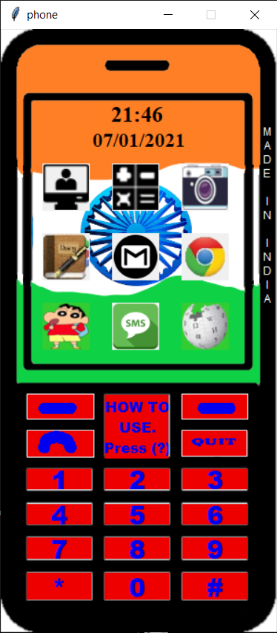



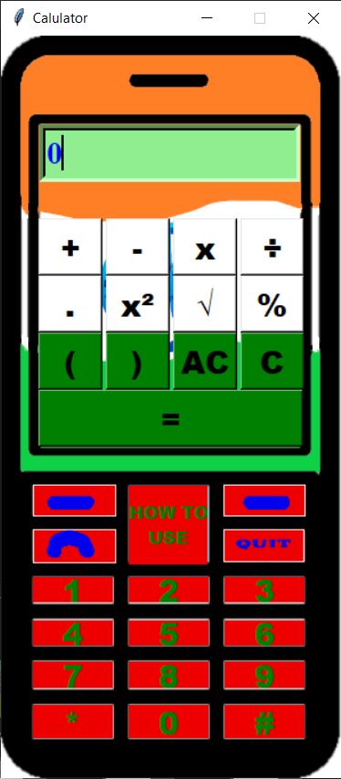

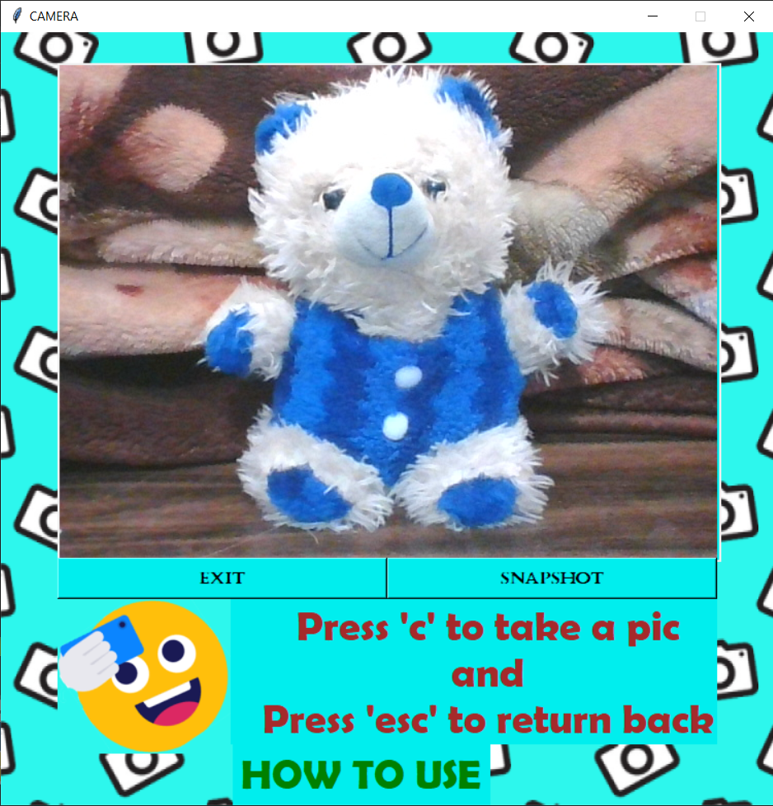

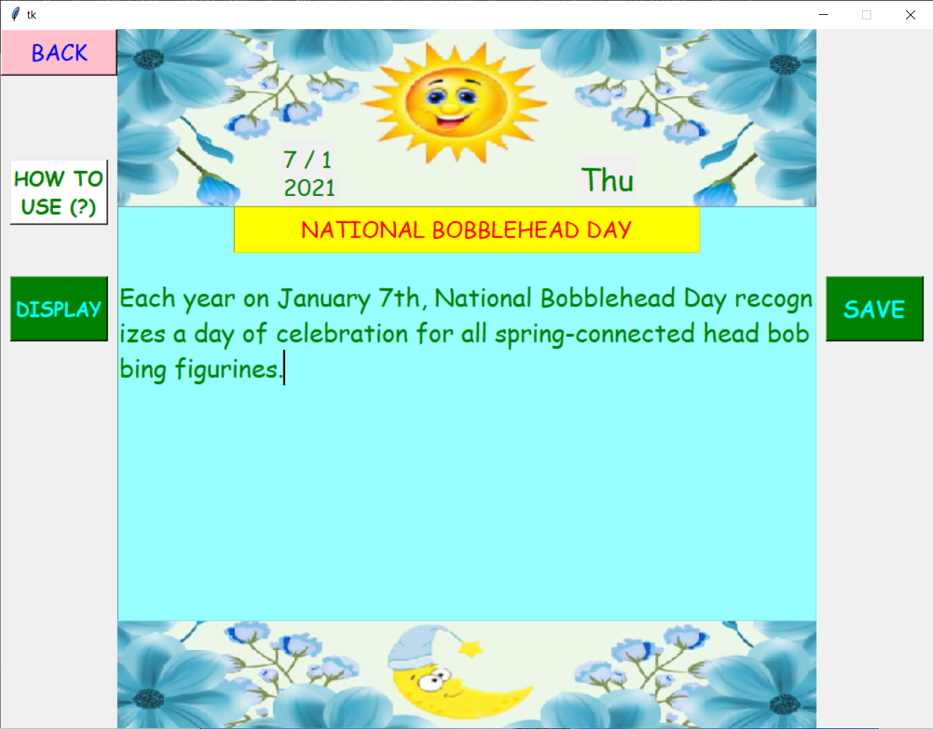

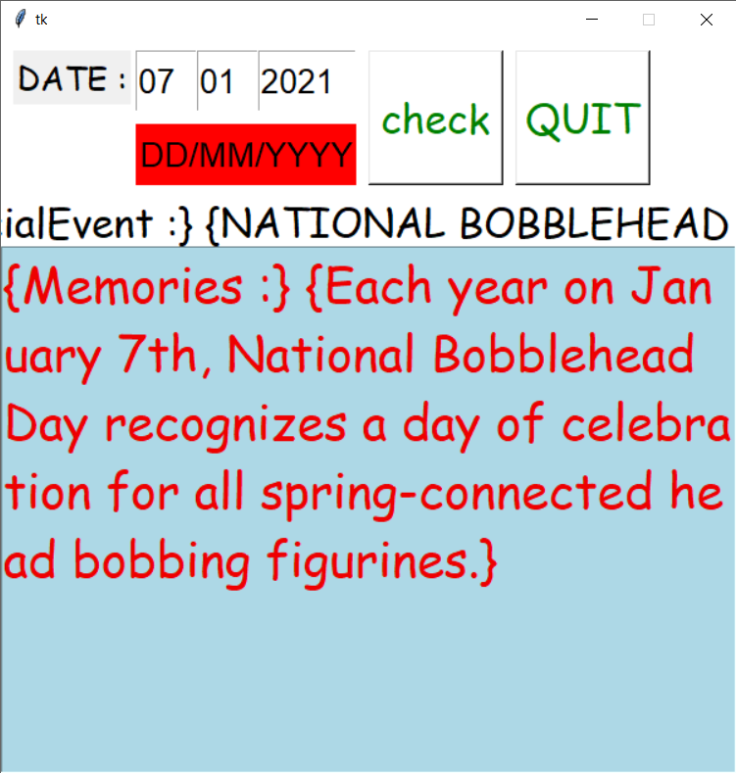

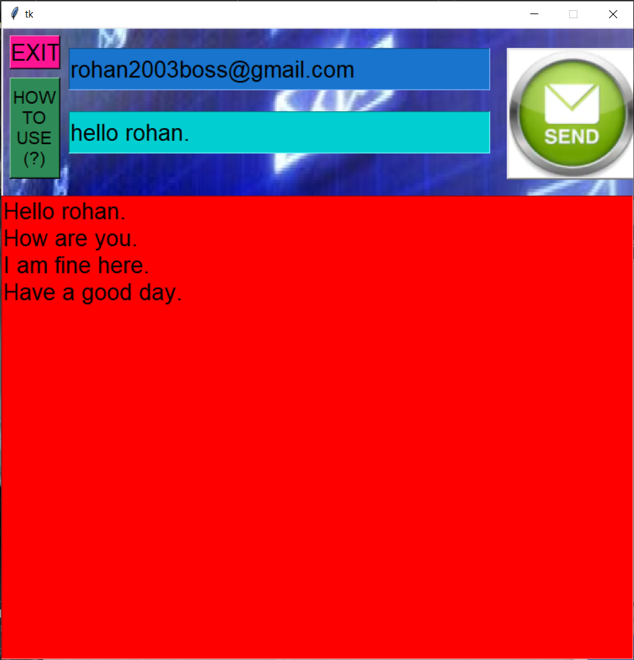

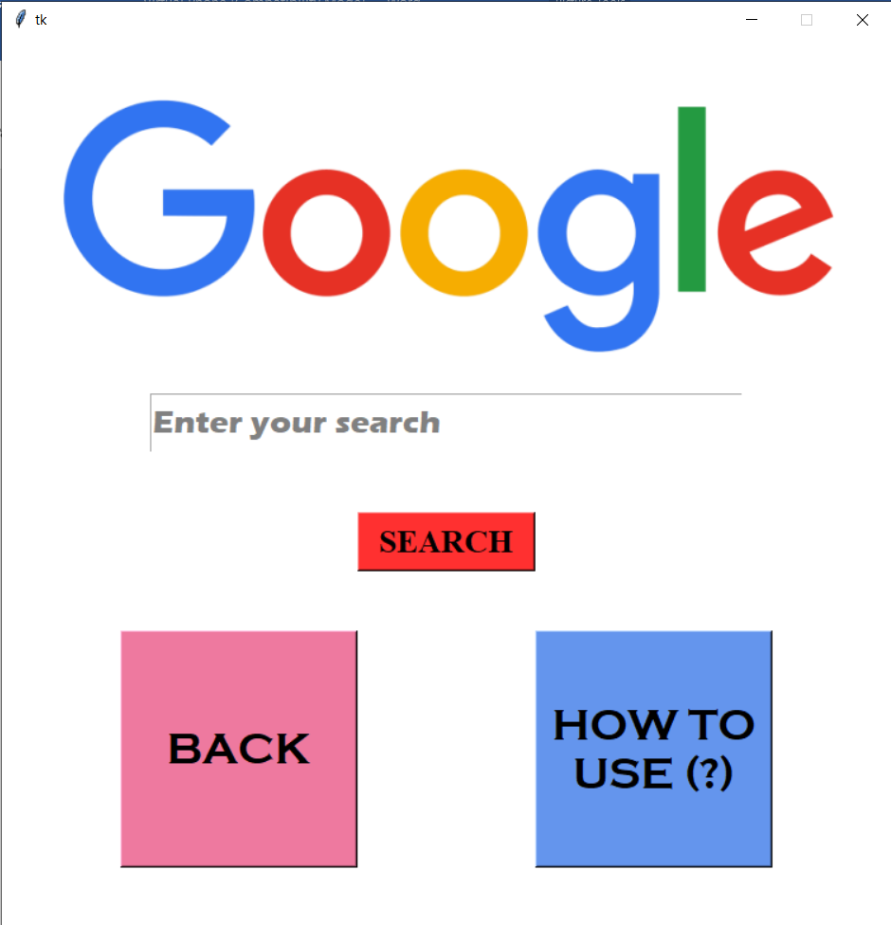

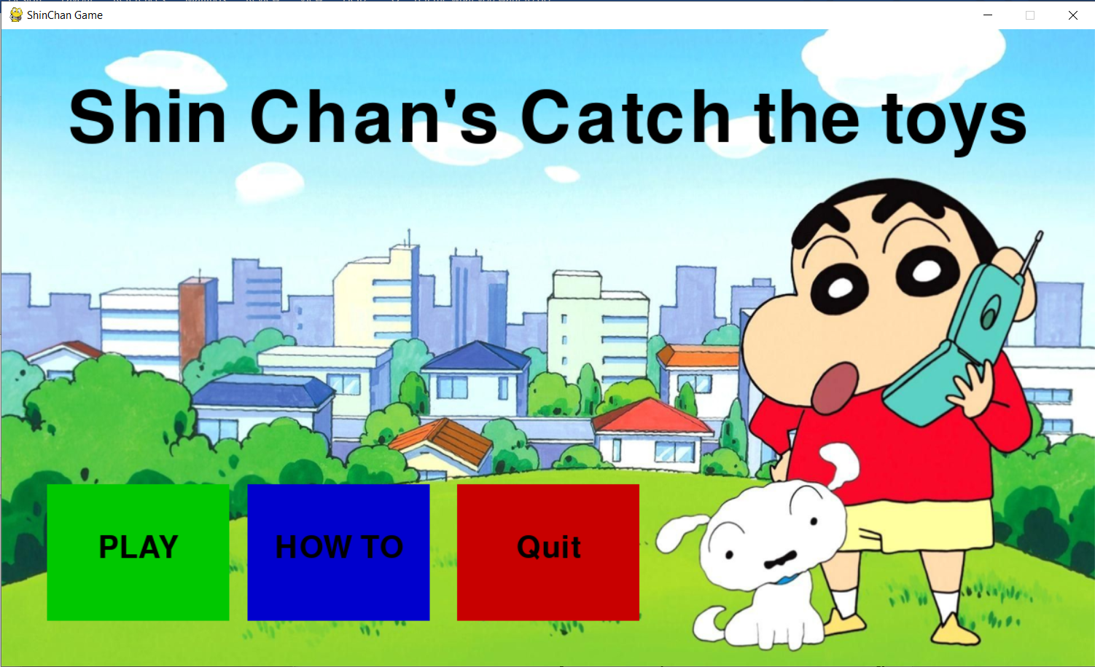

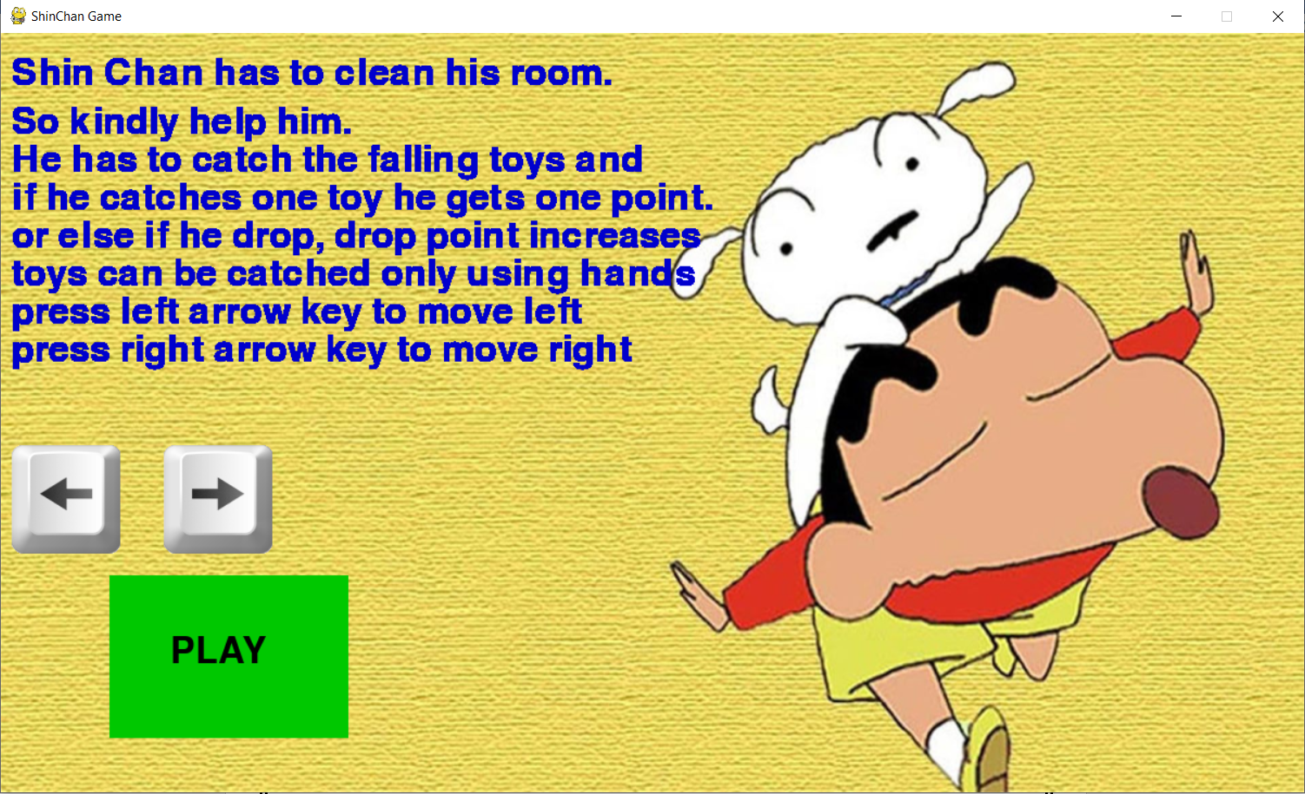

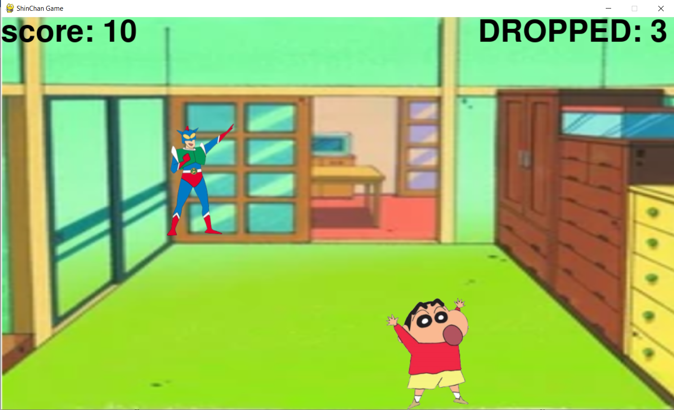

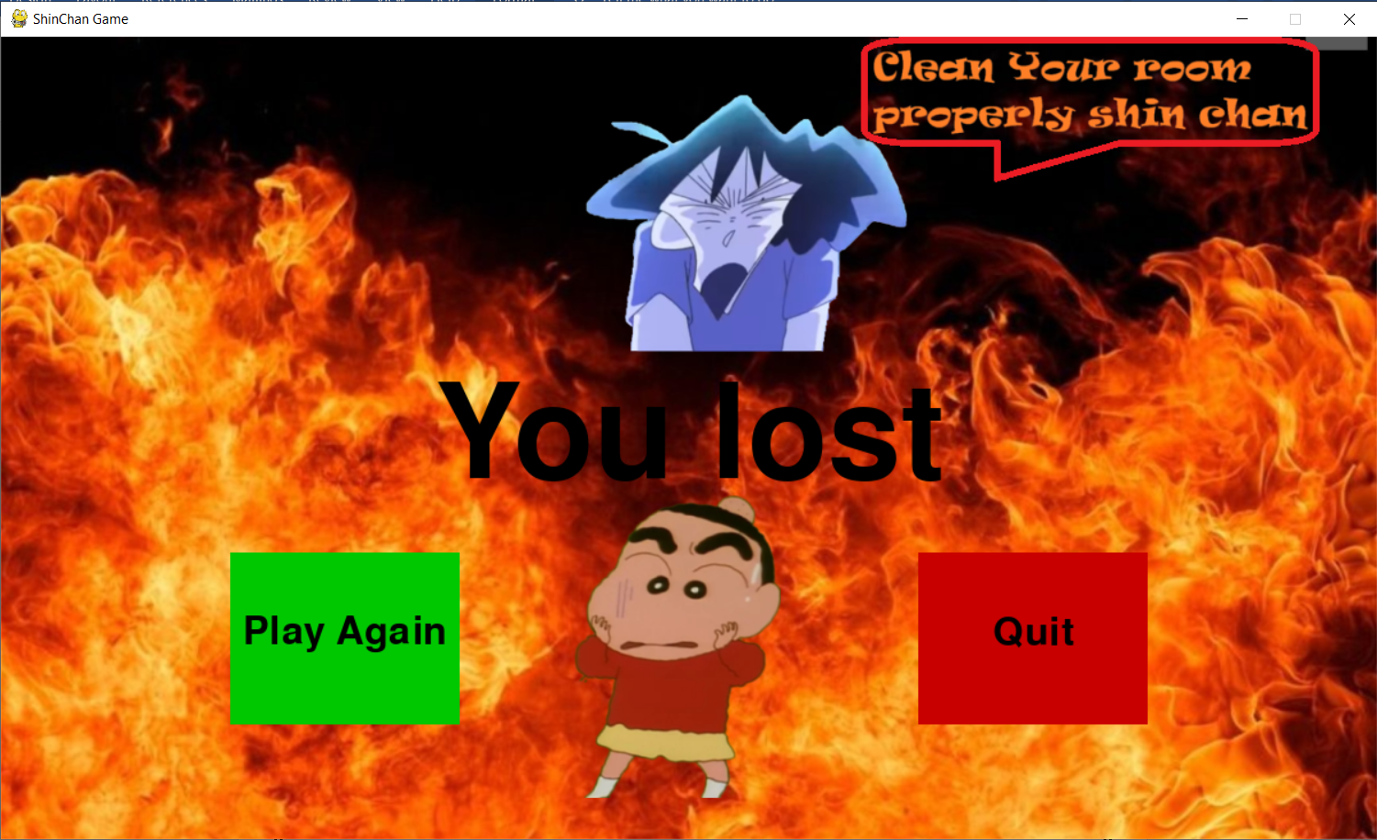

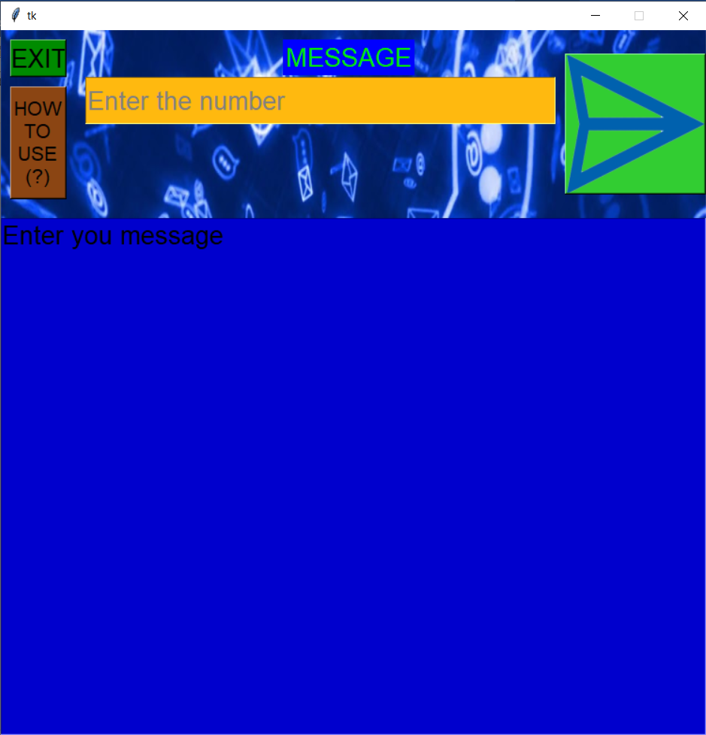

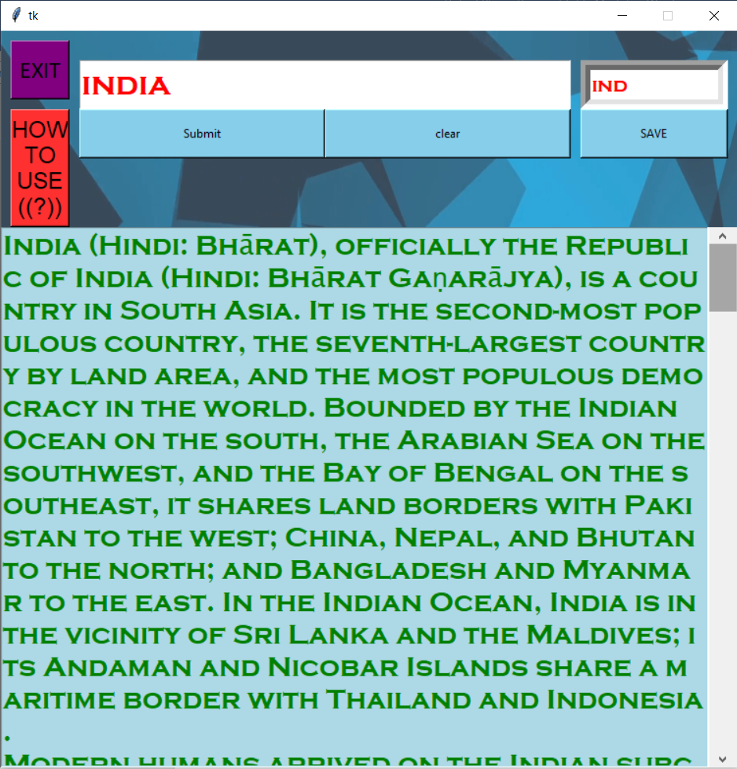

**Conclusion**

This can be developed by:

* Adding some more apps and a sliding window.
* When the phone is newly opened a welcome message can be played.
* New features can be added to all apps.
* The phone can be locked using a password unless the used gives the right password.

**Reference**

I have mentioned some of the reference ULR

* <https://www.geeksforgeeks.org/python-gui-tkinter/>
* <https://effbot.org/tkinterbook/tkinter-events-and-bindings.htm>
* <https://opencv-python-tutroals.readthedocs.io/en/latest/py_tutorials/py_setup/py_intro/py_intro.html>
* <https://realpython.com/python-csv/>
* <https://pynput.readthedocs.io/en/latest/keyboard.html>
* <https://www.tutorialspoint.com/simple-gui-calculator-using-tkinter-in-python>
* <https://www.pygame.org/news>
* <https://docs.fast2sms.com/#overview>
* <https://www.educative.io/edpresso/how-to-send-emails-using-python>
* <https://www.geeksforgeeks.org/wikipedia-module-in-python/>
* <https://pyttsx3.readthedocs.io/en/latest/engine.html>
* <https://pythonbasics.org/python-play-sound/>
* <https://pillow.readthedocs.io/en/3.0.x/handbook/tutorial.html>

***THANK YOU***